University Of Engineering and Technology, Lahore
Computer Engineering Department

Course Name: Programming Fundamentals | Course Code: CMPE-112L
Assignment Type: Lab tasks | Dated: 27 April 2026
Semester: First | Session: 2026 Spring
Lab/Project/Assignment #: 1 | CLOs to be covered: CLO 3
Lab Title: List, Tuple | Teacher Name: Hafiz Muhammad Mubashar
Lab Evaluation:

CLO3 | Apply appropriate programming techniques to create executable programs to solve well defined problems
CLO3 | Level1 | Level2 | Level3 | Level4 | Level5 | Level6
(5)
Total |  |  |  |  |  | /5
Rubrics for Current Lab Evaluation
Scale | Marks | Level | Rubric
Excellent | 5 | L1 | Submitted all lab tasks, BONUS task, have good understanding.
Very Good | 4 | L2 | Submitted the lab tasks but have good understanding
Good | 3 | L3 | Submitted the lab tasks but have weak understanding.
Basic | 2 | L4 | Submitted the lab tasks but have no understanding.
Barely Acceptable | 1 | L5 | Submitted only one lab task.
Not Acceptable | 0 | L6 | Did not attempt
Week 7 LAB
List, Tuple
Lab Goals/Objectives:
• To understand and manipulate ordered sequences in Python using lists and tuples.
• To master the concept of mutability versus immutability and how it dictates data modification.
• To practice item indexing, item extraction, and in-place list modification methods.
Equipment Required:

* Computer/Laptop
* Python 3.14
* VS Code or pycharm

Theory:
Python provides different built-in data types to store collections of items. Two of the most commonly used sequence types are Lists and Tuples.
Lab Work:

Task 1: List Creation and In-Place Appending
a = [1, "Ali", 2.1]
a.append("bilal")
print(a)
Result:

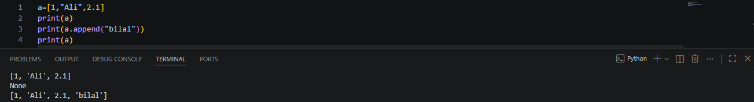

Task 2 Modifying List Elements via Indexing
b = [10, 20, 30]
b[1] = 99
print(b)
Result:
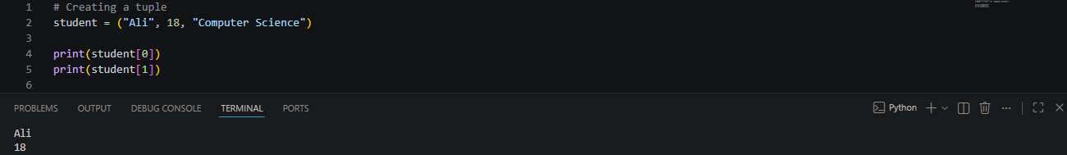

Task 3: Tuple Creation and Immutable Data Access

student = ("Ali", 18, "Computer Science")
print(student[0])
print(student[1])

Result:
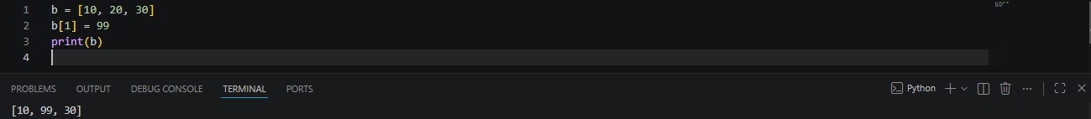

Conclusions:
This lab successfully demonstrates the practical behavioral distinctions between lists and tuples in Python. While both store sequences of mixed data types and allow access via index values, lists offer dynamic structural flexibility through mutability and in-place methods, whereas tuples provide data protection and structure through forced immutabi

